Expand wireless signal through Universal Repeater
Model number: A8
Sometimes the wireless router is too far from the wireless clients or the wireless signal strength is too low to connect, in order to expand the wireless coverage of your existed wireless, you can use another wireless router to setup Universal Repeater Mode with the existed wireless.
Part 1: The example Topology
Part 2: Settings in Uplink A8
Part 3: Settings in Downlink A8
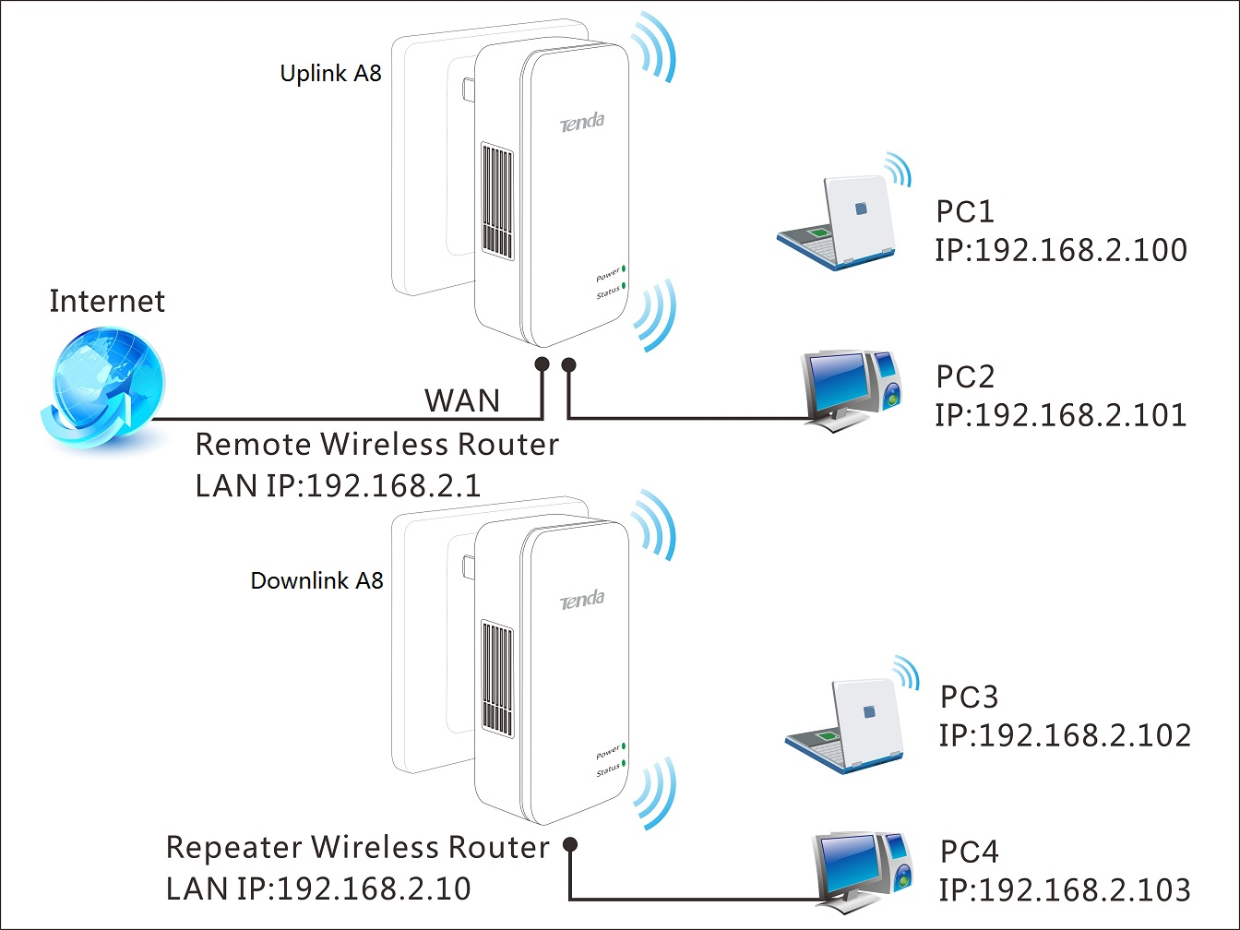
1 Login the Home page of Uplink A8, ensure it can connect to Internet.
2 Enable DHCP in Uplink A8 or Downlink A8, and set all PCs to obtain an IP address automatically.
3 About how to configure wireless function in Uplink A8, you may refer to recommend configurations.
- Network Mode: 11b/g/n mixed mode
- Channel: 11 or 6
- Security Mode: WPA-PSK
- Algorithms: WPA
1 Open a web browser in PC4 which connects to Downlink A8 (LAN port), and in the address bar please type in 192.168.2.1, and then click Enter, then you will login the Home page of A8.
2 Click Setup to go to select Universal Repeater Mode, then click Next.
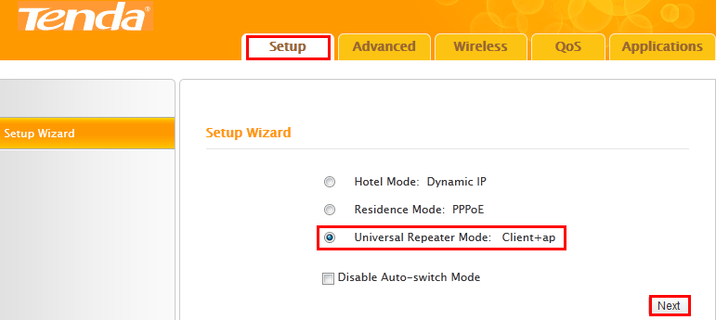

3 Click on Scan, you will see a list of SSID, select expected SSID and set Security Mode & WPA Algorithms etc.
a) We set Uplink A8 wireless SSID as “Tenda_chxsc”, Channel as 6, Security Mode as WPA-PSK, WPA Algorithms as AES, Security Key as 123456789 in this example topology.
b) We must ensure the information in below, refer to picture below, then click Next to continue.
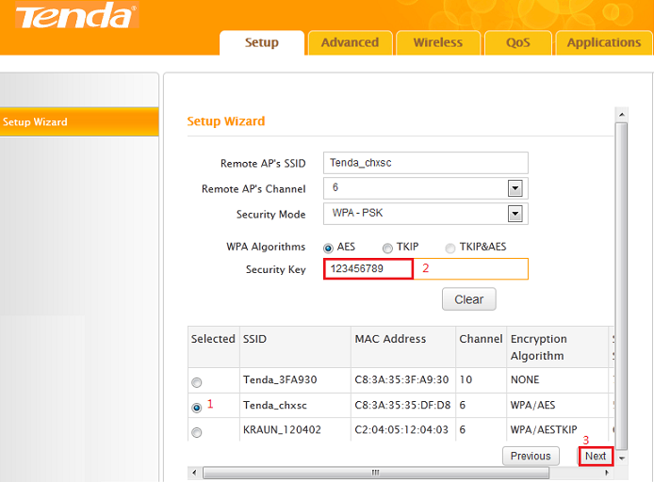
4 Set Uplink A8 Wireless parameters (SSID, Security Mode, Algorithms and Key) refer to below picture. Click Next to continue.
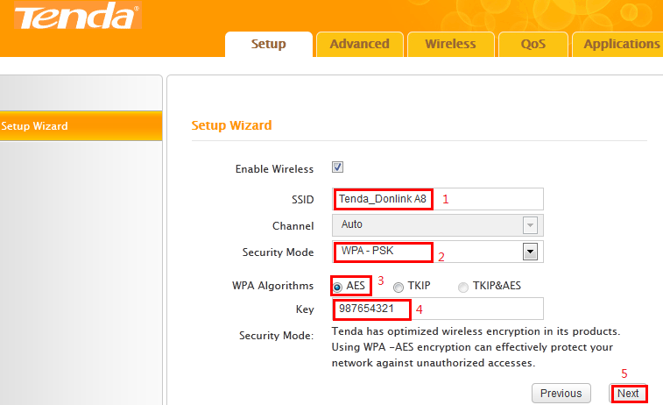
5 Click Finish and wait for the device to restart automatically. After reboot, reconnect to this device wirelessly or using an Ethernet cable and you will be able to access Internet.

